
Local Guideline

Preoperative Anaesthetic Clinic preparation of patients who refuse blood product transfusion presenting for elective surgery at JHH
Sites where Local Guideline applies |  |  | John Hunter Hospital
This Local Guideline applies to:
- Adults |  |  | Yes
- Children up to 16 years |  |  | No
- Neonates – less than 29 days |  |  | No
Target audience |  |  | Anaesthetists, perioperative nurses, surgeons, haematologists
Description |  |  | This guideline details the pathway for perioperative assessment and management of patients who refuse blood products before elective surgery.
 | Go to Guideline
Keywords |  |  | Jehovah’s Witness, anaemia, perioperative, erythropoiesis stimulating agents, iron
Document registration number
Replaces existing document? |  |  | No
Related Legislation, Australian Standard, NSW Ministry of Health Policy Directive or Guideline, National Safety and Quality Health Service Standard (NSQHSS) and/or other, HNE Health Document, Professional Guideline, Code of Practice or Ethics:
- See Reference Section on page 5
Prerequisites (if required) |  | Patients should be booked for elective surgery at John Hunter Hospital and should be identified as refusing of blood products.
Local Guideline note |  | This document reflects what is currently regarded as safe and appropriate practice. This guideline does not replace the need for the application of clinical judgment in respect to each individual patient. If staff believe that the guideline should not apply in a particular clinical situation they must seek advice from their unit manager/delegate and document the variance in the patient’s health record.  If this document needs to be utilised outside of the John Hunter Hospital please liaise with the local Perioperative and Haematology Services to ensure the appropriateness of the information contained within the Guideline and Procedure.
Position responsible for the Local Guideline and authorised by |  | Perioperative Executive Committee
Contact person |  | Dr Paul Healey (Perioperative Service Director)
Contact details |  | Paul.healey@health.nsw.gov.au, (02) 49332018
Date authorised
This document contains advice on therapeutics |  | Yes  (If Yes) Approval gained from Local Quality Use of Medicines Committee on (insert date)
Issue date
Review date |  | Up to 3 years

Note: Over time links in this document may cease working. Where this occurs please source the document in the PPG Directory at: http://ppg.hne.health.nsw.gov.au/

PURPOSE AND RISKS
Some patients refuse blood and blood products. In particular, Jehovah’s Witnesses have specific religious beliefs regarding transfusion although acceptance of minor blood fractions or procedures involving the use of their own blood may vary subject to their conscience views (see Appendix 1 for Jehovah’s Witnesses’ position on blood products) (1,2).
A fully informed, competent adult is entitled to decide to accept or refuse medical treatments. A patient is competent to refuse treatment if they can demonstrate an understanding of the nature of their condition, the nature and consequences of the treatment being refused and the possible consequences of the refusal of treatment. Medical staff have an obligation to provide any patient with all the information necessary to enable that patient to make an informed decision and to answer any relevant questions the patient may have. Further, staff have an obligation to satisfy themselves that a patient is fully informed before that patient makes a decision to accept or refuse treatment. (1,2)
The outcomes of preoperative anaesthetic consultation of the patient who refuse blood product transfusion should include the following (3):
- Patients should be given a clear explanation of the blood products that the medical team might consider to be required during or after surgery and the risks involved if they refuse, including death. Discussion of alternative treatments should be undertaken if available.
- There should be clear documentation in the medical records of which treatments and/or procedures the patient consents to and which they do not.
- Patients’ haemoglobin concentration and iron stores should be optimised.
- Perioperative management of medications that affect coagulation should be documented.
Risk Category: Clinical Care & Patient Safety

GLOSSARY
Acronym or Term | Definition
ACD | Advance Care Directive
APTT | Activated partial thromboplastin time
CAP | Clinical Applications Portal
EPO | Erythropoietin
ESA | Erythropoiesis stimulating agent
FBC | Full blood count
JW | Jehovah’s Witness
PT | Prothrombin time

GUIDELINE
This Guideline does not replace the need for the application of clinical judgment in respect to each individual patient.

Preoperative management of patients who refuse blood products should involve the following steps(4)

- Identification and/or documentation of informed Advanced Care Directive
- See Flowchart 1 below
- Further useful information to guide informed decision making can be found in Appendix 1
- Examples of advanced care directives for patients who refuse blood transfusions include:
  - Jehovah Witness “No blood” Advanced care directive (Appendix 2)
  - Refusal/Consent to blood products and conservation (Appendix 3)

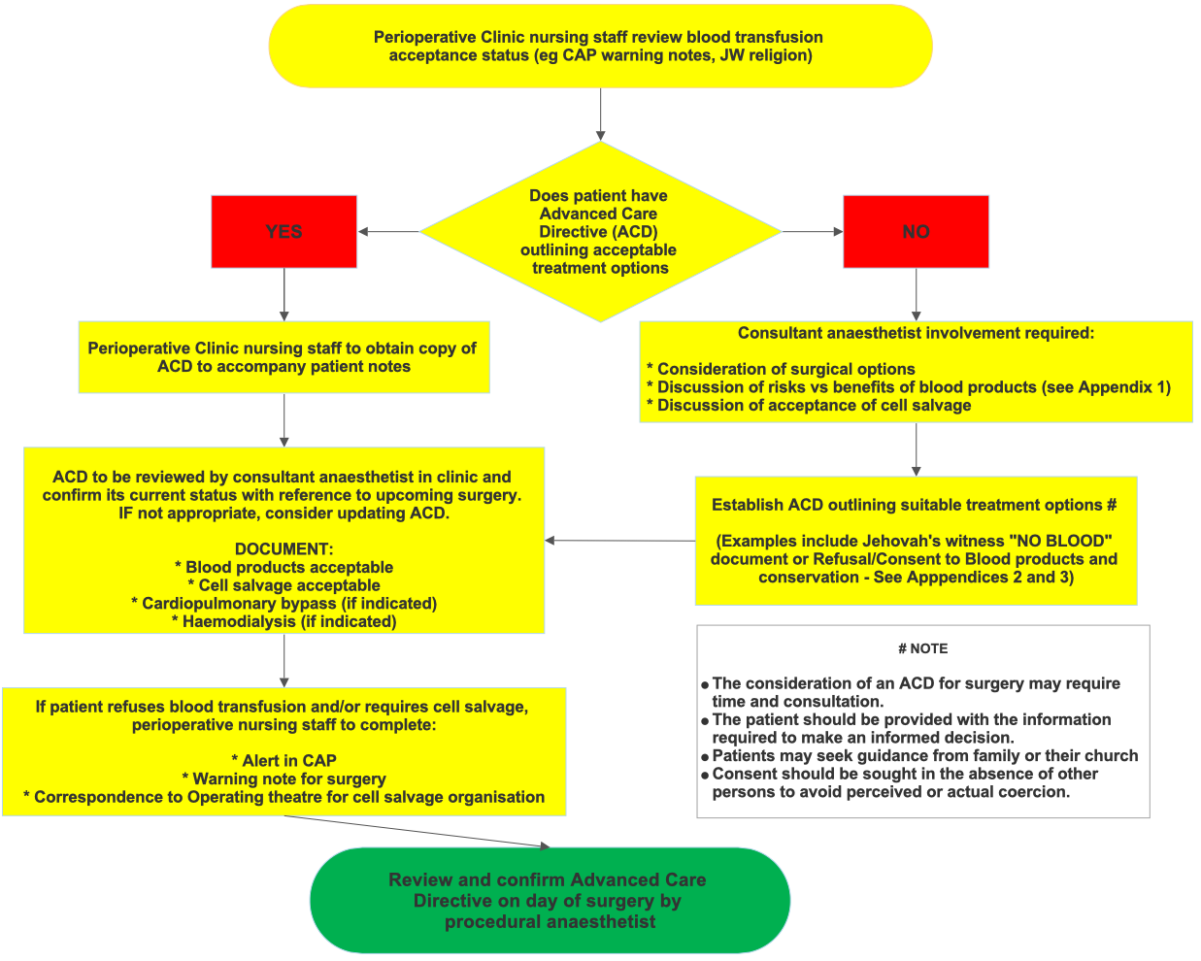
Flowchart 1: Advance care directive for blood products

- Identification of patients having major surgery and significant risk of transfusion and/or bleeding (see Flowchart 2 below)
- Optimisation of Hb and iron stores before major surgery (see JHH Local Guideline – Management of Preoperative Anaemia). This may delay surgery – consult surgeon.
- Perioperative management of antiplatelet and anticoagulant medication (see JHH Local Guideline – Perioperative Management of Medications)
- Cell salvage if appropriate and acceptable
- Consideration of erythropoiesis stimulating agents (see JHH Local Guideline – Perioperative use of Erythropoesis stimulating agents). This may delay surgery – consult surgeon.
Flowchart 2: Identification of major surgery and haemoglobin optimisation
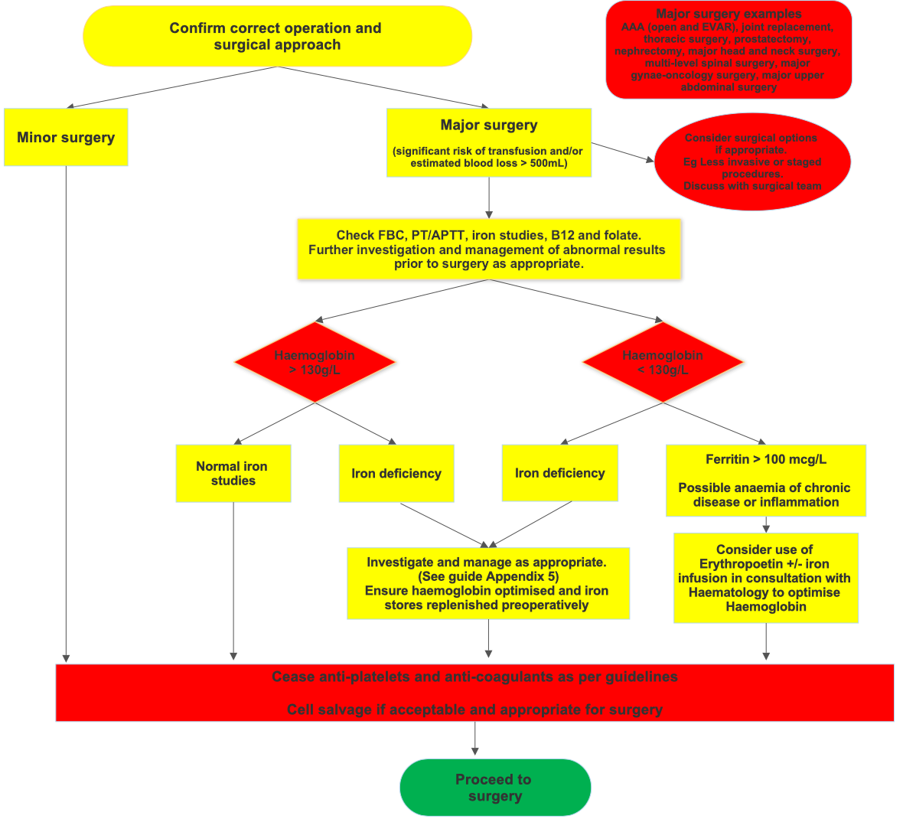

- Consultation with surgical team:
- If unaware of patient refusal of blood products
- If consideration of alternate surgical procedure is appropriate
- If delay in surgery required to optimise iron stores or reduce bleeding risk

- Discussion of potential risks of surgery and blood product refusal must be discussed with patient and documented, including death.

Implementation, Monitoring Compliance AND AUDIT
This document was developed in conjunction with the John Hunter Hospital Anaesthetic Department, Perioperative Departments, Blood Transfusion Committee and Surgical Services.
The guideline will be communicated to the relevant departments through presentation at continuing medical education meetings and made available electronically through the Policies Procedures and Guidelines intranet page.
As this document pertains to a very small group of patients, compliance will be monitored on a case-by-case basis by the Haematology and Perioperative Services.

APPENDICES
Appendix 1: Blood products and synthetic alternatives, for informed discussion with a patient who refused a blood transfusion.
Appendix 2: Jehovah Witness “No blood” Advanced care example
Appendix 3: Refusal/Consent to blood products and conservation

REFERENCES
- Considerations in the management of pregnant women who refuse blood and blood products. Queensland Maternal and Perinatal Quality Council. Accessed July 2021: https://www.health.qld.gov.au/__data/assets/pdf_file/0020/440156/qmpqc-guidance-refuse-blood.pdf
- Austin Health Clinical Guideline: Management of Patients who refuse blood and blood products – Jehovah’s Witnesses.
- Klein, A.A., Bailey, C.R., Charlton, A., Lawson, C., Nimmo, A.F., Payne, S., Ruck Keene, A., Shortland, R., Smith, J., Torella, F. and Wade, P. (2019), Association of Anaesthetists: anaesthesia and peri-operative care for Jehovah's Witnesses and patients who refuse blood. Anaesthesia, 74: 74-82. https://doi.org/10.1111/anae.14441
- Chae C, Okocha O, Sweitzer B. Preoperative considerations for Jehovah's Witness patients: a clinical guide. Curr Opin Anaesthesiol. 2020 Jun;33(3):432-440. doi: 10.1097/ACO.0000000000000871. PMID: 32371641.
- Western Health Alert 15 refusal consent to blood, blood products and conservation: https://www2.health.vic.gov.au/about/publications/policiesandguidelines/western-health-refusal-consent-blood-products-conservation
- National Blood Authority Australia (2016) : Iron product choice and dose calculation for adults. https://www.blood.gov.au/system/files/documents/Iron%20product%20choice%20and%20dose%20calculation20052016.pdf
- Munoz M, Acheson AG, Auerbach M, et al. International consensus statement on the peri-operative management of anaemia and iron deficiency. Anaesthesia 2017; 72: 233–47.
- Richards T, et al. Preoperative intravenous iron to treat anaemia before major abdominal surgery (PREVENTT): a randomised, double-blind, controlled trial. Lancet. 2020 Oct 24;396(10259):1353-1361. doi: 10.1016/S0140-6736(20)31539-7.

Useful Links
https://intranet.hne.health.nsw.gov.au/QUMC_JHH/_guidelines_protocols_forms
Patient Blood Management Guidelines: Module 2 Perioperative : https://www.blood.gov.au/pbm-module-2

FEEDBACK
Any feedback on this document should be sent to the Contact Officer listed on the front page.

Appendix 1: Blood products and synthetic alternatives | Mostly Unacceptable
 | May be acceptable
Adapted from Western Health and Preoperative considerations for Jehovah’s Witness patients Chae et al. | Usually acceptable

BLOOD COMPONENTS The 4 main components can be separated and used for treatment.
Red Blood Cells (Erythrocytes, RBCs) Red cell component of whole blood, carries oxygen around the body, given RBCs if blood count is too low.

White Blood Cells (Granulocytes, WBCs) White cell component of whole blood used for preventing infections

Platelets (Thrombocytes) small cells without a nucleus found in large numbers in blood. Requited to make clots that prevent or stop bleeding. Given if bleeding is hard to stop or if platelet count is very low.

Plasma (FFP) liquid portion of blood. Consists of water, albumin, clotting factors, salts, sugars, fats, vitamins, and hormones. Given if plasma or clotting factors required
FRACTIONATED PLASMA COMPONENTS separated from whole blood components
Albumin 4% and 20%: Protein purified from plasma which helps maintain fluid in the circulation.

Cryoprecipitate: Concentrated solution of specific protein molecules (FVIII, FXIII, Von Willebrand, Fibrinogen, Fibronectin) involved in blood clotting – made from plasma

Factor Concentrates:
Prothrombinex-VF: Concentrated factor II, IX and X and low levels of factors V and VII. These are proteins which are essential for the normal blood clotting process. Used in the reversal of warfarin and for factor deficiencies
Biostate: Factor VIII/Von Willebrands factor Complex. Both FVIII and VWF are blood proteins that are essential for normal blood clotting.
Mono-FIX: Concentrated factor IX, a protein which is essential for normal blood clotting.
Thrombotrol (antithrombin III): Used to prevent and treat blood clots in people who have an inherited deficiency of antithrombin III
Fibrinogen concentrate: Concentrated factor I. Used in setting of factor deficiency or perioperative bleeding.
AUTOLOGOUS BLOOD
Intra-operative red cell salvage: Collection, washing and re-transfusion of own blood directly aspirated from the surgical field. Does not contain coagulation factors

Epidural Blood patch: Accomplished by injection of patient’s own blood into the epidural space
EXTRACORPOREAL CIRCULATION
Cardiopulmonary bypass: Temporarily takes over function of the heart and lungs by mechanically circulating and oxygenating blood through a machine in a continuous circuit.

Haemodialysis: Removes waste and fluid from the blood in renal failure
SYNTHETIC RECOMBINANT PRODUCTS
Erythropoietin (EPO) : Synthetic proteins used to stimulate the production of red blood cells

Recombinant Factor VIIa (NovoSeven) Synthetic protein used in major bleeding and for patients with FVIII and IX inhibitors

Recombinant FVIII and IX: Synthetic protein used in haemophilia

Appendix 2: Jehovah’s witness “No blood” Advanced Care Directive

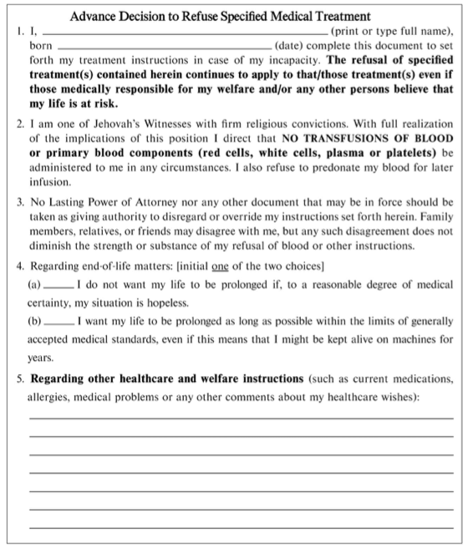
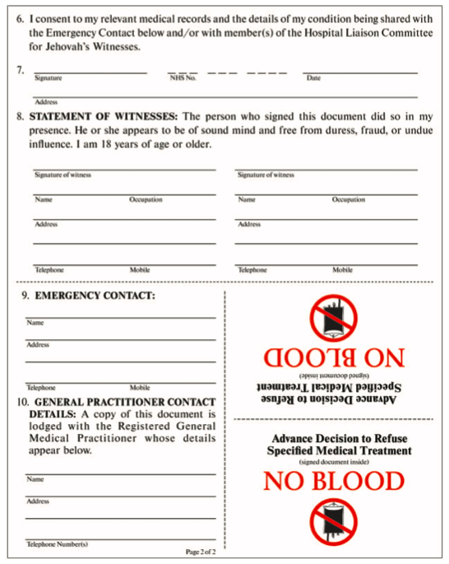

Appendix 3: Refusal/Consent to blood products and conservation (5)

